**Clifton Recreation Department Presents**

**2025 CITYWIDE PHOTO SCAVENGER HUNT**



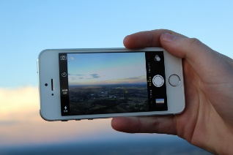

**SATURDAY, June 7, 2025**

**Registration:** Register online at www.cliftonnj.org

**Cost:** $15.00 per team. Teams consist of 2 – 4 members.

**Time:** 8:45 a.m. start and your last photo must be in by 6:00 p.m. You may use as much of

the day as you choose.

**Location:** Clifton Municipal Complex – 900 Clifton Avenue, Clifton, NJ 07013

**Requirement:** Participants must be able to upload to Google Forms on their phone for photo submission.

**Procedures:** Teams will search from a list of items at the various garage sales being conducted at the Citywide Garage Sale. There are opportunities for additional points for various submissions (such as creative photos, number of garage sales visited, unique locations, etc.). This is not a race but a contest to gather the most points. You will have the full day to obtain as many points as you can. This will also give you time to shop at the garage sales for treasures you may want for yourself.

The garage sale locations will be available between June 2nd and June 5th and the photo list will be distributed the morning of the event, June 7th.

On the morning of the Citywide Garage Sale, the Scavenger Hunt will begin at the City Hall Complex – on the front steps of City Hall. Your entire team must be present at 8:45 a.m. to take a team photo and receive your team wristbands. At 9:15/9:30 a.m., you will receive your list of items to find and opportunities to obtain additional points.

The last photo must be submitted by 6:00 p.m. and points will be tabulated the week of Monday, June 9th. Prizes will be issued to the top 3 teams and winners will be notified on Monday June 16, 2025.

**Rules:** You may have up to 4 members on your team. Items must be found at one of the garage sales listed on the Citywide Garage Sale sheet but you can only find a maximum of 2 scavenger hunt items per garage sale location. You do not have to purchase the items you find, but the submitted photo must be taken at the location where you found the item. The photo must contain at least 2 or more of your team members with the item and your wristbands showing.

You must be respectful in the manner in which you search for items. Remember you are visiting people’s homes. The Garage Sale participants will be issued a phone number to report any scavenger hunt participants that are disrespectful and disruptive in their search and will result in losing team points.

